Screen Shot 1 – FN+ PrntScrn
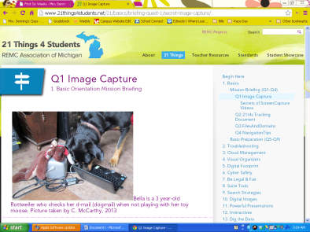

Screenshot 2 – Alt+Fn+PrntScrn
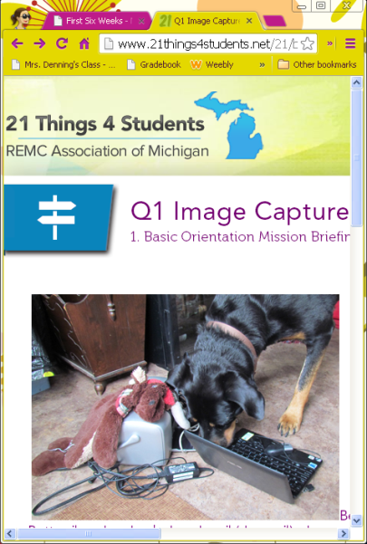
Difference between 2 screen shots
3 ways you can use this in your classes

