Moses Austin

***Development***

**Problem:**

**Goal:**

**Outcome:**

***Personal Impression***

**Personal Impression:**

***Memorable Interactions***

**Quote:**

**Action:**

**Interactions:**

***Major Events***

**Events:**

**Response:**

***Background***

**Time Period:**

**Location:**

**Role:**

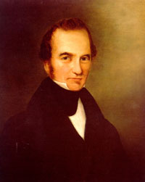

Stephen F. Austin

***Development***

**Problem:**

**Goal:**

**Outcome:**

***Personal Impression***

**Personal Impression:**

***Memorable Interactions***

**Quote:**

**Action:**

**Interactions:**

***Major Events***

**Events:**

**Response:**

***Background***

**Time Period:**

**Location:**

**Role:**

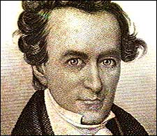

Martin deLeon

***Development***

**Problem:**

**Goal:**

**Outcome:**

***Personal Impression***

**Personal Impression:**

***Memorable Interactions***

**Quote:**

**Action:**

**Interactions:**

***Major Events***

**Events:**

**Response:**

***Background***

**Time Period:**

**Location:**

**Role:**

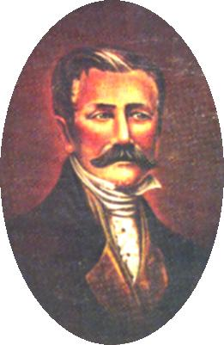

Green DeWitt

***Development***

**Problem:**

**Goal:**

**Outcome:**

***Personal Impression***

**Personal Impression:**

***Memorable Interactions***

**Quote:**

**Action:**

**Interactions:**

***Major Events***

**Events:**

**Response:**

***Background***

**Time Period:**

**Location:**

**Role:**

